ClockFOUR Chronogram Test and Assembly Plan
09 October, 2015
David Pincus
V1.0
Overview:
Chronogram is a clock that tells the time with words. It has a 14x13 RGB pixel matrix that is powered by an external 5V 3A power supply.

Functionality to be tested:
PCB assembly
Visual inspection
- Visually inspect each board for defects
Vibration and flex test
- Gently flex and twist the PCBA
- Tap the board several times on each side on a hard surface (like a table)
- Run your hand and fingers over each component to ensure they are not loose
Flash bootloader using ICSP
- Successfully flash the Arduino bootloader onto the board using the ICSP header (with pogo pins)
Flash code using FTDI
- Successfully upload the ClockFOUR software using the FTDI header
- Disconnect the FTDI header
Smoke test
- Connect the external power supply (Solder the power jack to the board with wires included in the kit BOM)
- Examine the board for any signs of heat or smoke
Self test mode
- Restart the clock by pressing the reset button once
- While the welcome message scrolls across the display press either MODE or COLOR button once
- When the message has finished scrolling the clock will enter self test mode
- The LEDs will light up sequentially RED, GREEN and BLUE and then repeat
- Check that all 182 LEDs each display red, green and blue correctly, at the same brightness level
- Press either MODE or COLOR button once and the clock will begin displaying all time words rapidly in bright white
- Check that all LEDs have the same consistent brightness. If you see any colors something is wrong and the board is defective!
- Pressing MODE or COLOR to exit self test mode and return to normal time mode
Button and user interface test
- Check to make sure the clock is working properly
- Tap the color button to cycle between all white, solid color, slow color fade, rainbow color fade, party mode (rapid random colors) and then back to all white
- Press and hold the color button to display the color picker (large color circle)
- The circle will slowly fade between all colors
- Release the button and the clock should enter normal time mode with the solid color shown on the color picker
- Press the mode button once to display seconds mode
- Press the mode button again to return to time mode
- Press and hold the mode button to set the time (displays “SET” and “H” and then a large digits)
- Tap the color button to increment the hour
- Press and hold the color button to quickly increment numbers
- Press the mode button once to lock in the hour and change to set minute mode (displays “SET” and “M” and then two large digits
- Press color button to advance minutes; press and hold to advance quickly
- Press mode to lock in the selected time and advance to set brightness
- A large sun icon will be shown followed by the letter “A” or 1 to 5 increasing “signal bars”.
- Press color button to switch between “A” (for automatic brightness control), 1 bar (for minimum brightness), 2 bars, 3 bars, 4 bars, 5 bars (maximum brightness), and then back to “A”uto. Check that the brightness changes with each selection.
- Press mode to lock in the selected brightness and return to normal time mode with the newly set time.
Light sensor test
- There is one light sensor on top of the PCBA pointed upwards
- IMPORTANT: make sure clock brightness is set to “A” automatic mode (see above for instructions)
- Put the clock into a dimly lit room (almost completely dark) the clock should automatically dim
- Check that the clock returns to full brightness in normal daylight or when a bright light is pointed at the sensor
Battery backup test
- Ensure the backup battery (CR2032) is installed correctly
- Disconnect the power supply
- Wait 2-3 minutes
- Reconnect the power supply and verify that the correct time is still shown

Faceplate inspection and manufacturer acceptance criteria
Paint quality inspection (from the front)
- Examine the face plate with a bright lamp
- The surface should be uniform and even without any paint defects
  - No scratches
  - No streaks
  - No small pin holes where light can shine
- Fail any faceplate with any signs of drips or paint tears
Light leak test (from the rear)
- Place a bright light behind the faceplate while looking at the front. Look for pinhole sized light leaks coming through any scratches or paint defects
- Fail the faceplate if any small light leaks are present

Final assembly and inspection
Attach the PCB to the backplate: Push four 16-18 mm M3 screws through the backplate (from behind). For each of the four PCB screws add two localizer washers (2 x 2mm thick washers), the PCB, a third 2mm washer and finally a M3 nut as shown in the diagram below.
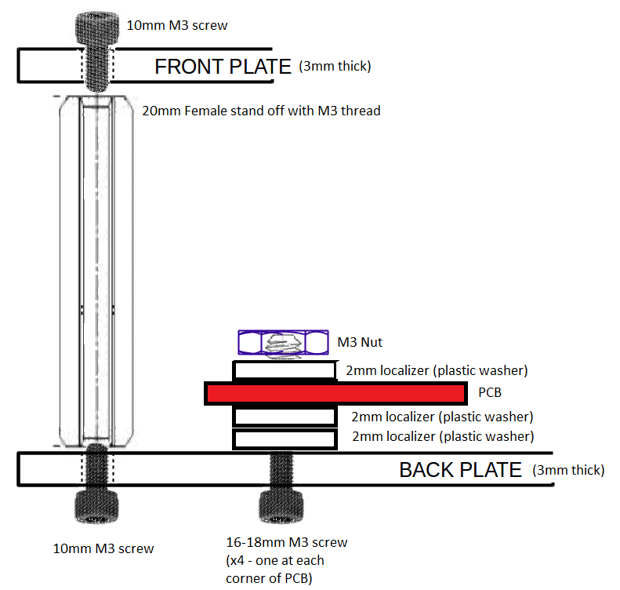
Solder wires to the power socket and solder the other end of the wires to the PCB.
Install the power socket to the backplate using the supplied washer and lock nut.
Next, assemble the baffle grid using the supplied 2mm black acrylic pieces. The vertical baffles face upwards while the horizontal pieces face downward. The horizontal pieces have an extra “lip” on the edge of each baffle that hangs over the left and right edge of the PCB.
IMPORTANT: Glue the left most and right most end horizontal pieces to each vertical baffle using a drop of liquid glue made specifically for plastic. Place a drop of glue along each baffle as shown. Use a t-square to ensure the baffles remain at 90 degree angles. Failure follow this step means the baffles will fall apart upon assembly and not stay in their correct position.
PHOTO OF BAFFLE ASSEMBLY HERE

Once assembled the localizer washers should not allow any vertical movement and the horizontal “lips” should only allow 1 mm of movement side to side.
Next, tape a piece of velum (thin white typing paper) the back side of the faceplate over the etched letters. This is to defuse the light and allow even illumination.
The faceplate is installed as shown in the above diagram. The four 20mm female M3 posts are attached by a 10mm M3 screw on each side.
Check to make sure the baffles have been installed correctly and sit flush with the faceplate.
Before closing and packing the clock it is vital to check that the baffles are assembled and installed correctly. Use the clock’s self test mode to check that every letter is illuminated fully and is not cut off. If any letters are cut off the baffles are not installed correctly and must be adjusted!

Final quality check and packaging
Faceplate and backplate scratch films in place
Minimise fingerprints on clock surfaces
Check included, but not installed items (rubber feet, instructions page, etc)
Clock is securely packed

